Proposal

- Introduction:
  - Background Information: This project is about a comparative analysis of the 3 datasets, examining the relationship between life expectancy, health expenditure, positive affect, and total health issues such as depression. The results indicate that many social, economic, and health factors are associated with depression, but further research is required to draw definitive conclusions.
  - Motivation: This project lies in understanding the intricate relationship between life expectancy, health expenditure, positive affect, and total health issues, particularly depression. By examining these factors collectively, the study aims to shed light on potential causative or correlational relationships among them. Given the increasing global burden of mental health disorders, especially depression, it is crucial to investigate its potential determinants and their interplay. Additionally, by discerning the influence of health expenditures on life expectancy and mental well-being, policy-makers can make informed decisions regarding healthcare budgets and strategies. This analysis, therefore, has significant implications for public health, economics, and social policy, making it an important endeavour.
  - Overall Objective and Features: This project aims to conduct a comparative analysis of the 3 datasets, investigating the relationships between diverse indicators such as socio-economic, health, and political factors in different countries or regions with depression and other mental health issues. Using multidimensional data visualisation and geographical analysis techniques, these relationships are illustrated. Additionally, the project will undergo temporal analysis and correlation studies. Furthermore, considerations are made for data reliability within the analysis, and interpretations and conclusions are provided for the data obtained.
  - Limitations of Traditional Computing Solutions: The traditional computing solutions often lack the scalability, the flexibility, and the cost-efficiency needed for the large-scale data projects, struggling with the limited storage, the collaboration challenges, and the manual maintenance, making them less suited for the complex analyses like the multidimensional visualization and the geographical studies. The traditional computing solutions often exhibit limitations when handling such complex projects.
  - Benefits: The cloud computing offers the scalability, the cost-effectiveness, and the real-time collaboration, making it ideal for this project. Its vast storage capabilities and processing power support the multidimensional data visualisation, the geographical analysis, and the diverse indicators assessment. Furthermore, the cloud platforms ensure the data reliability, facilitate the temporal and the correlation studies, and streamline the interpretations and the conclusions, enhancing the overall efficiency and the depth of the analysis.
- Technical Solutions:
  - Cloud Computing Technologies: The Google Cloud Compute Engine was utilised, which is an Infrastructure as a Service (IaaS) offering, to provide the scalable virtual machine instances. These instances were then integrated with the Hadoop (HDFS), a distributed file system designed to hold the very large amounts of data and provide the high-throughput access to this information. Additionally, Apache Spark was employed as the core tool for the big data processing and analytics. The Docker container technology was also utilised for the component and the application management within the project. The synergy of these technologies and tools enabled the efficient data storage, the processing, the complex data analysis, and the streamlined application deployment and management, providing the robust support and the flexibility for this complex data project.
  - Monthly Cost Estimation: The VM instance is the primary source of the cost in this project.

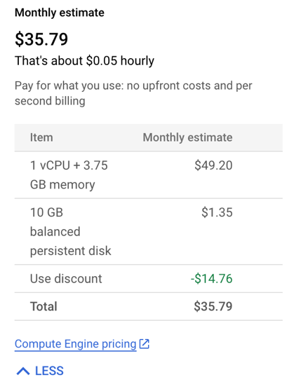

- Architecture Design (workflow/framework):

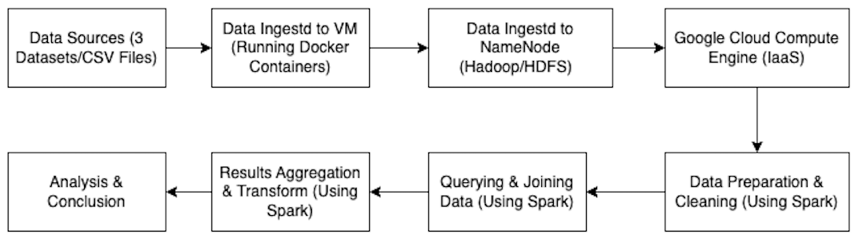

This architecture design illustrates the complete workflow of obtaining data from the 3 data sources, ingesting it through VM (running Docker containers) and NameNode (Hadoop/HDFS), processing it on the Google Cloud Compute Engine, using Spark for the data preparation, cleaning, querying, and joining, culminating in the results aggregation and analysis.

